Selecting the snapshot

* Go to EC2 dashboard in EBS and click on *Snapshot*

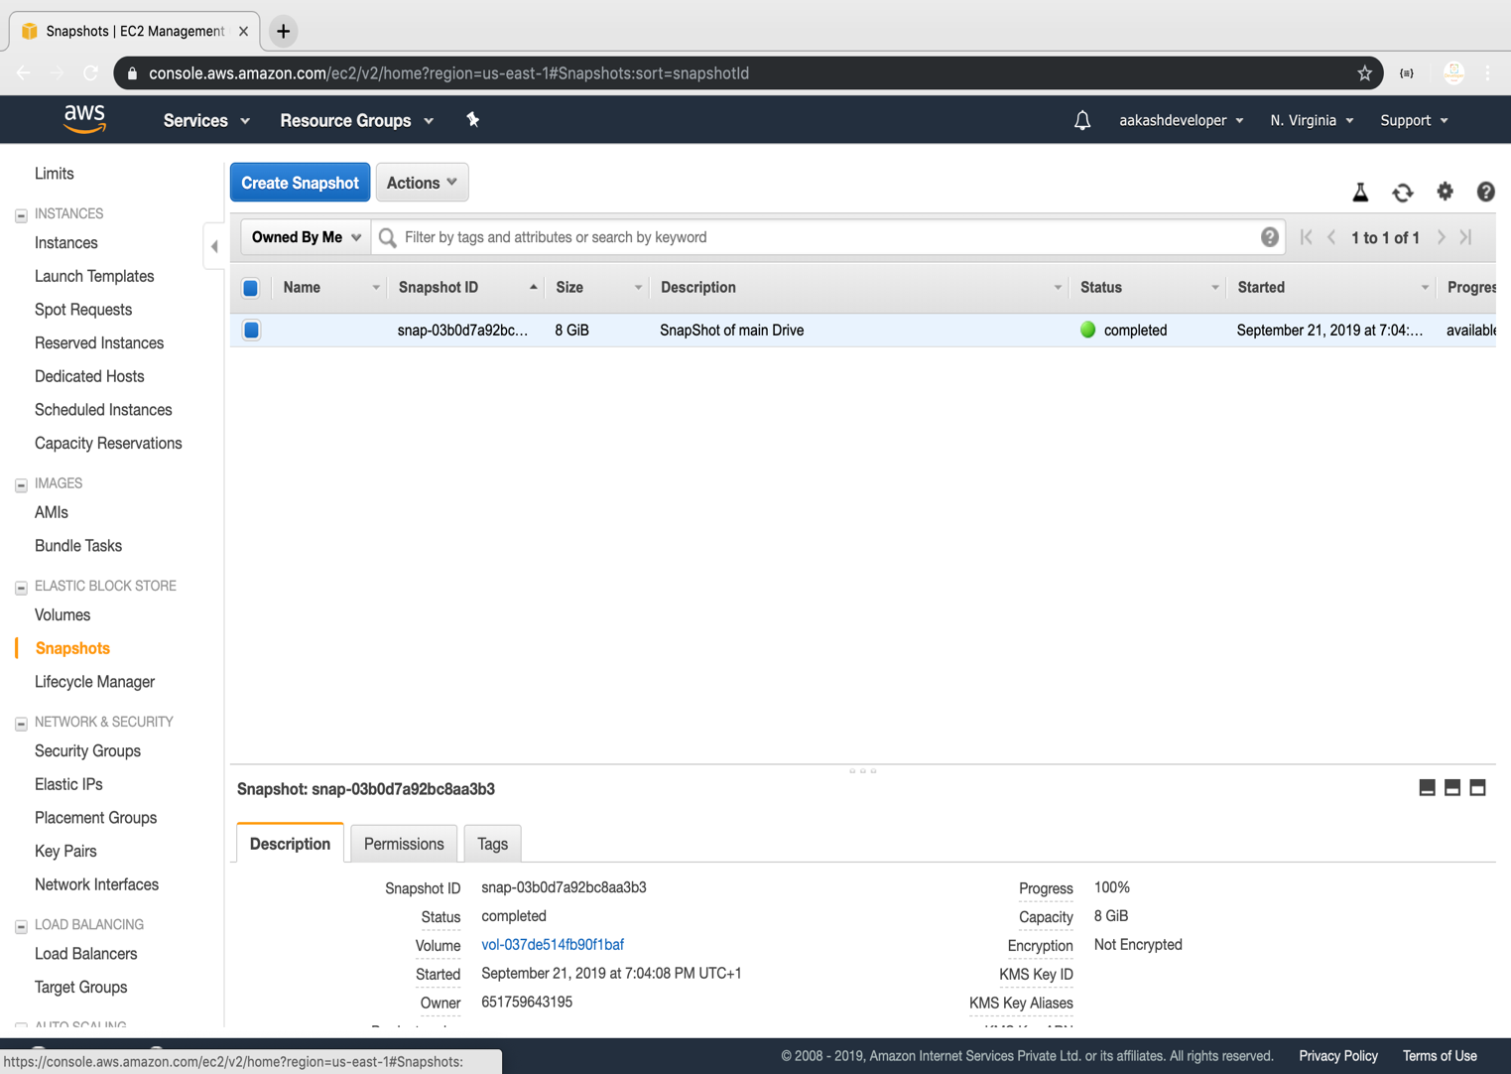

Restoring volume from the snapshot

* Select the snapshot and click on *Action*

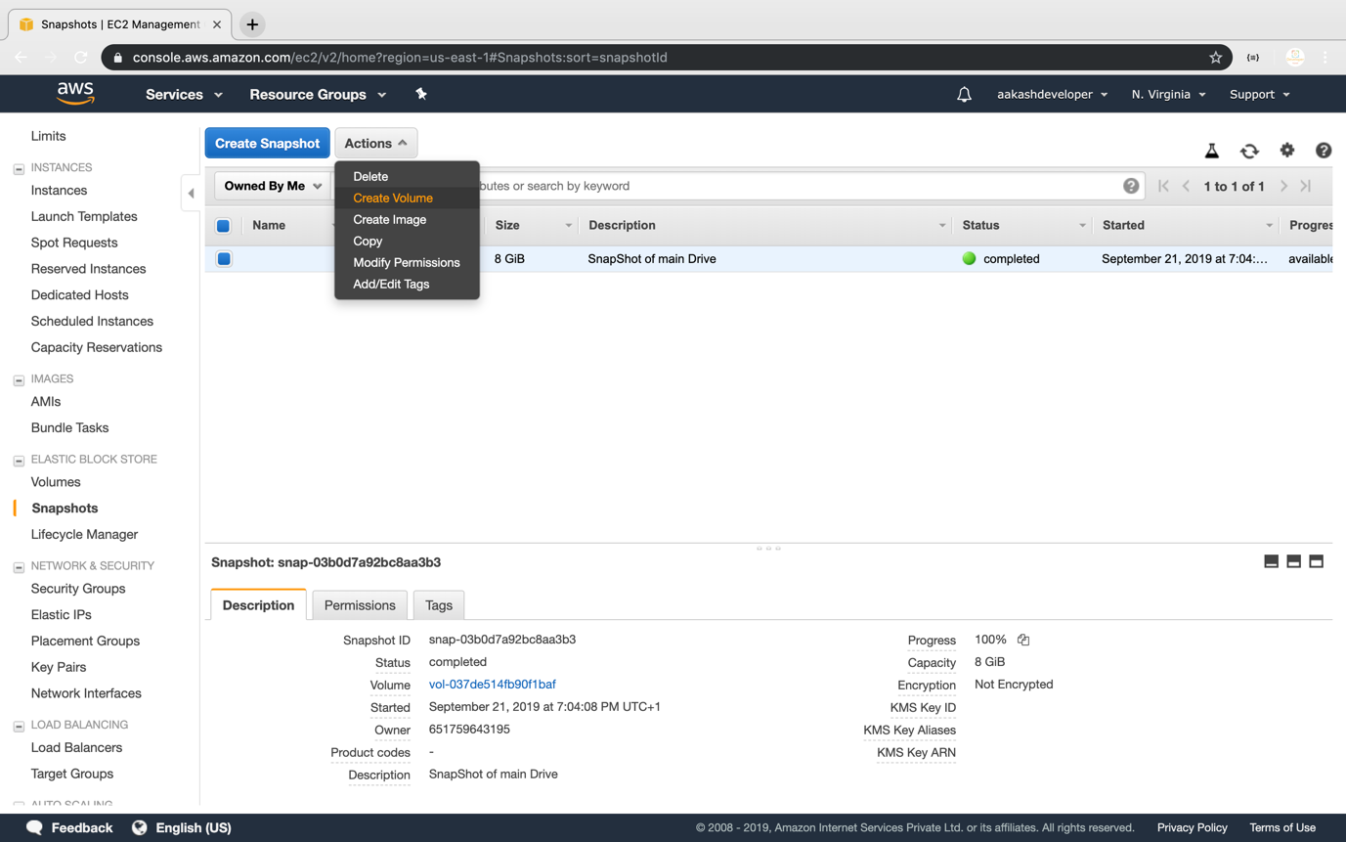

* You can specify the key and value to identify the volume

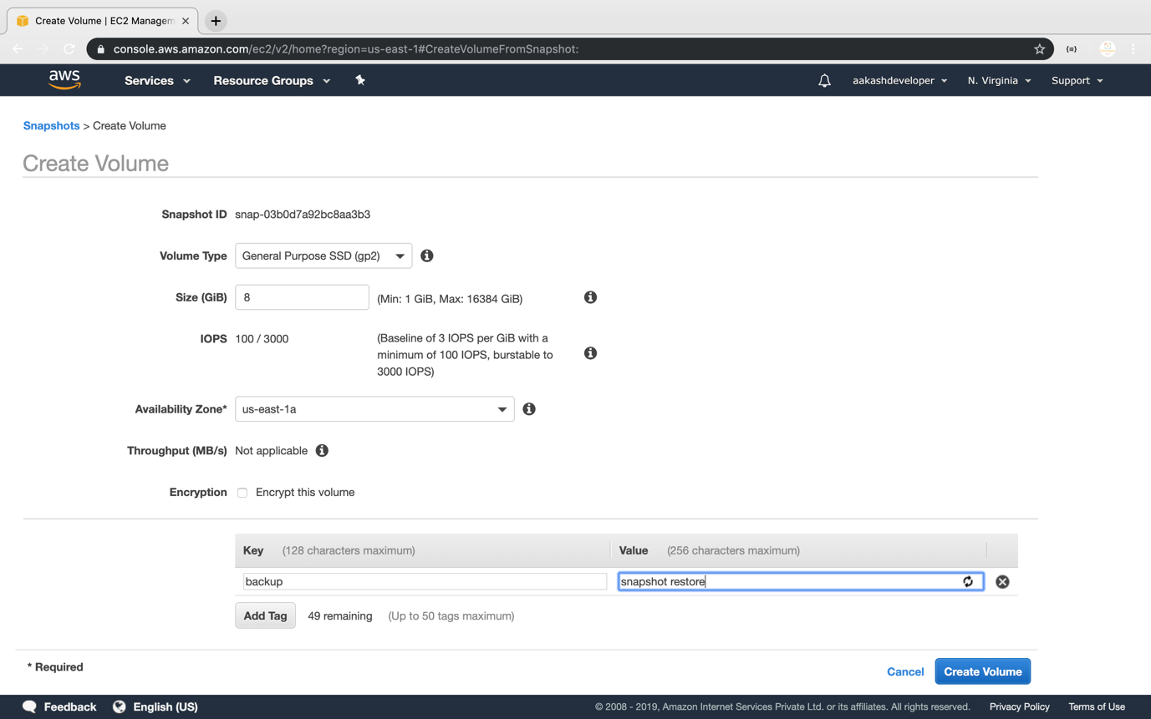

* Restore the volume from the snapshot

